Goal: MicroSD Card module with RP2350

Components:
- RP2350
  - Two hardware SPI controllers
- MicroSD Socket: Molex 104031-0811
  - Has active microSD connector, surface-mount, card-detection switch, easily available
- 3.3V Regulator: AP2112K-3.3TRG1
- Capacitors
  - 10uF electrolytic for input and output
  - 0.1 uF ceramic for SD decoupling
  - 4.7uF for SD bulk
- Resistors
  - Pull up resistors
  - Series for reducing ringing on SPI signals
- ESD Protection
  - TPD4E05U06
- Header pins
- Through-hole pads

Design:
https://www.nxp.com/docs/en/application-note/DRM125.pdf 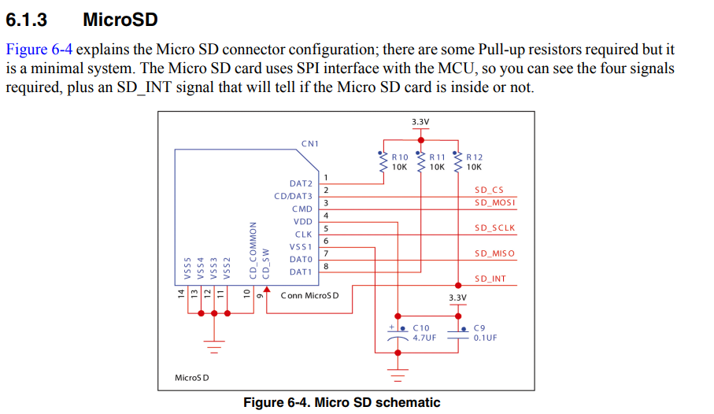
Overall design is a 5V input with 3V regulator

